**Project Design Phase-II**

**Data Flow Diagram & User Stories**

|  |  |
| --- | --- |
| Date | 19 September 2023 |
| Team ID | **593090** |
| Project Name | |  | | --- | | TrafficTelligence: Advanced Traffic  Volume Estimation with Machine Learning | |  | |
| Maximum Marks | 4 Marks |

**Data Flow Diagrams:**

A Data Flow Diagram (DFD) is a traditional visual representation of the information flows within a system. A neat and clear DFD can depict the right amount of the system requirement graphically. It shows how data enters and leaves the system, what changes the information, and where data is stored.

**Example: (Simplified)**

**FLOW**

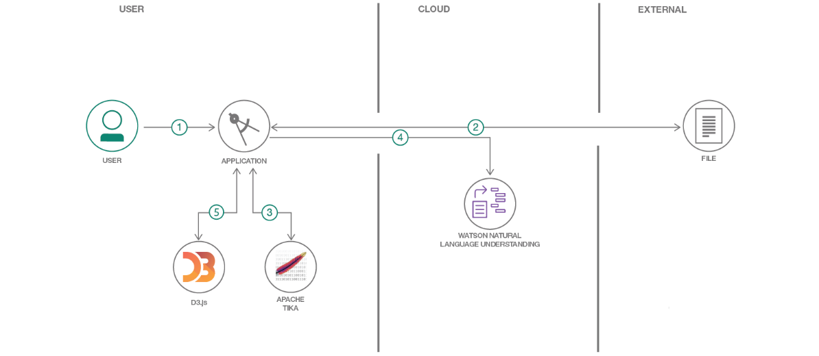 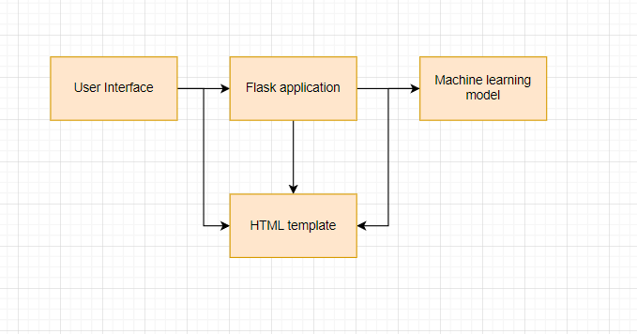

**User Stories**

Use the below template to list all the user stories for the product.

|  |  |  |  |  |  |  |
| --- | --- | --- | --- | --- | --- | --- |
| **User Type** | **Functional**  **Requirement**  **(Epic)** | **User Story Number** | **User Story / Task** | **Acceptance criteria** | **Priority** | **Release** |
| Customer  (Laptop user) | Project setup &  Infrastructure | USN-1 | USN-1 Set up the development environment with the required tools and frameworks to start the advanced traffic volume detection project. | Showing the approximately accurate traffic volume. | High | Sprint-1 |
| Administrator | development  environment | USN-2 | USN-2 Gather a diverse dataset of data containing traffic volume on different holiday (Diwali, Durga Puja, Chath Puja) for training the machine learning model. | The day is working or holiday | High | Sprint-1 |
| Administrator | Data collection | USN-3 | USN-3 Preprocess the collected dataset by removing the outlier and splitting it into training and testing or validation sets. | Data does not have any null values and does not contain outlier | High | Sprint-2 |
| Administrator | data preprocessing | USN-4 | USN-4 Explore and evaluate different machine learning architectures to select the most suitable model for advanced traffic volume detection. | The model is giving a higher accuracy | Medium | Sprint-2 |
| Administrator | model development | USN-5 | USN-5 train the selected machine learning model using the preprocessed dataset and monitor its performance on the testing or validation set. | The model is correctly predicting the traffic volume. | High | Sprint-3 |
| Administrator | Training | USN-6 | USN-6 implement accuracy improving techniques like hyperparameter tuning to improve the model's robustness and accuracy. | The accuracy is improved or the model is correctly predicting the traffic volume. | medium | Sprint-3 |
| (Web user) | model deployment & Integration | USN-7 | USN-7 deploy the trained machine learning model as an API or web service to make it accessible for advanced traffic volume detection.. integrate the model's API into a user-friendly web interface for users to upload images and receive traffic volume detection results. | The traffic volume for a particular day is shown. | medium | Sprint-4 |
| Customer Care Executive | Testing & quality assurance | USN-8 | USN-8 conduct thorough testing of the model and web interface to identify and report any issues or bugs. fine-tune the model hyperparameters and optimize its performance based on user  feedback and testing results. | The model is accurate in predicting the traffic volume. | medium | Sprint-5 |